Assignment 3

Saleha Iqbal Hussain

2011CS10252

# Question 3

## Part1

Average accuracy: - 99.42

## Part2

Random Accuracy – 12.5%

Increase – 7.95 times

## Part 3

No, each class has its own probability of words. Words in each class are determined from a set of examples. And thus this special case of examples just adds to the frequency if words. If the words used with a high frequency in one class over other, the classification would and should go in favor of that class. If both have nearly same frequency of words, then it doesn’t matter.

A problem will arise if these examples use words that have not been used before in any examples.

## Part 4

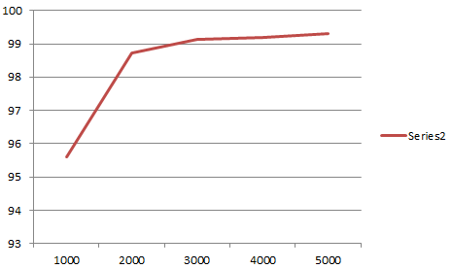

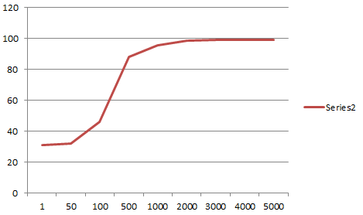

Very steep learning curve. It learns very quickly. It achieves 90% accuracy in about 500 examples. Rest was marginal improvement.

## Part5

The confusion matrix is attached.

Order

|  |  |  |  |  |  |  |  |  |
| --- | --- | --- | --- | --- | --- | --- | --- | --- |
|  | 'talk.politics.mideast' | 'rec.motorcycles' | 'rec.sport.baseball' | 'rec.sport.hockey' | 'talk.politics.misc' | 'talk.religion.misc' | 'talk.politics.guns' | 'rec.autos' |
| 'talk.politics.mideast' | 932 | 0 | 0 | 0 | 1 | 0 | 0 | 0 |
| 'rec.motorcycles' | 1 | 995 | 1 | 0 | 0 | 0 | 0 | 2 |
| 'rec.sport.baseball' | 2 | 0 | 991 | 1 | 1 | 0 | 0 | 1 |
| 'rec.sport.hockey' | 0 | 0 | 2 | 995 | 0 | 0 | 0 | 0 |
| 'talk.politics.misc' | 0 | 1 | 0 | 0 | 763 | 1 | 1 | 0 |
| 'talk.religion.misc' | 2 | 0 | 0 | 0 | 2 | 621 | 2 | 0 |
| 'talk.politics.guns' | 2 | 0 | 0 | 0 | 8 | 6 | 906 | 1 |
| 'rec.autos’ | 1 | 0 | 0 | 3 | 0 | 0 | 0 | 985 |

Highest diagonal entry – motorcycles and hockey

Highest non-diagonal entry – guns confused for politics.misc